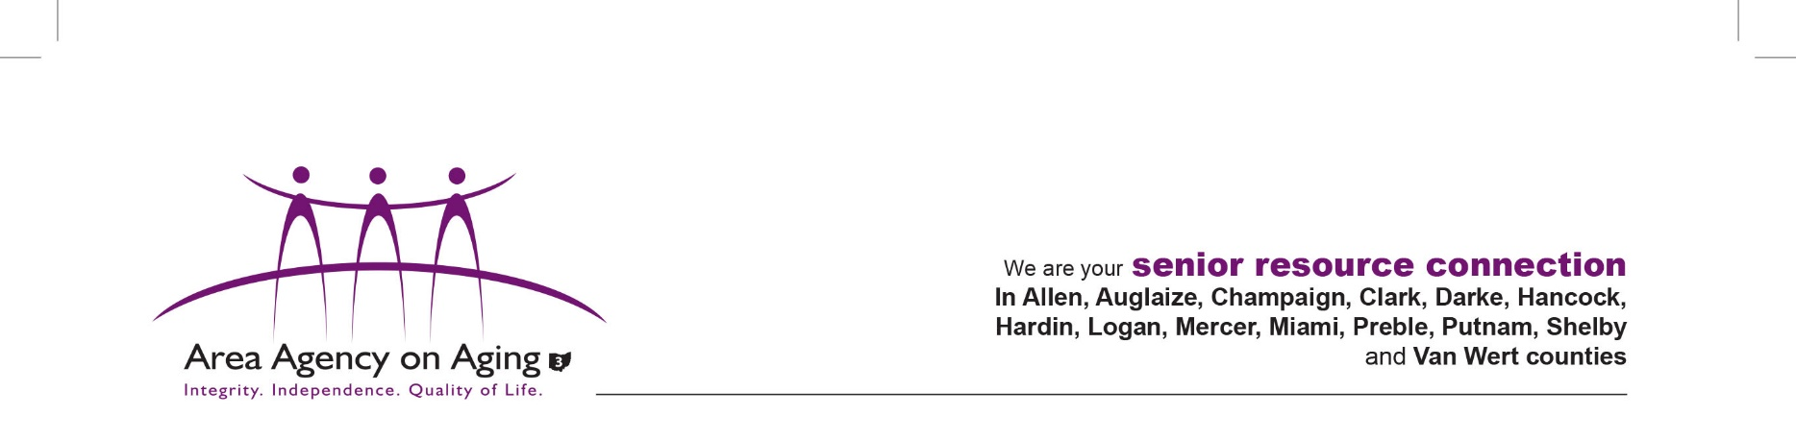

MEDIA PERMISSION FORM

I give permission to Area Agency on Aging 3 to visit my home for the purpose of promoting and advocating the program I utilize through this agency.

Without expectation of compensation, now or in the future, I hereby give my consent to the Area Agency on Aging 3 and their subsidiaries, affiliates, and agents, to use my image and likeness and/or any interview statements from me in its publications, advertising or other media activities (including the Internet). This consent includes, but is not limited to:

Please check the one that applies below:

_____ Permission to use my first name only, quotes from the interview(s) (or excerpts of such quotes), the film, photograph(s), tape(s) or reproduction(s) of me, and/or recording of my voice, in part or in whole, in its publications, in newspapers, magazines and other print media, on television, radio and electronic media (including the Internet), in theatrical media and/or in mailings for educational and awareness.

_____ I would prefer my visit be kept confidential between the parties involved and not used to promote the agency to the public.

______________________________ _______________

Individual Signature

______________________________ _______________

Agency Representative Date

If under 18, signature of Parent or Guardian:

______________________________ _______________

Date

Update 11.14.18